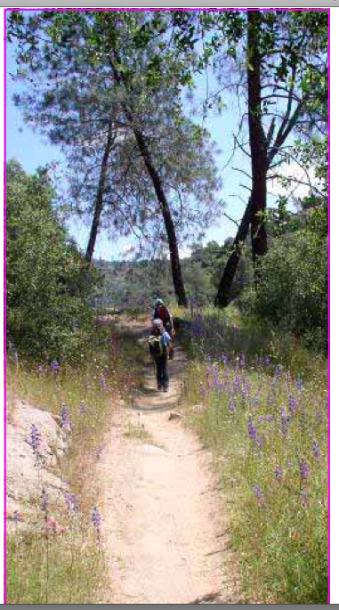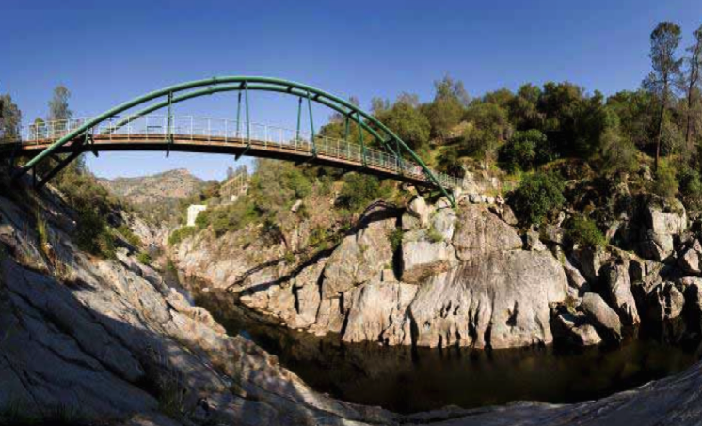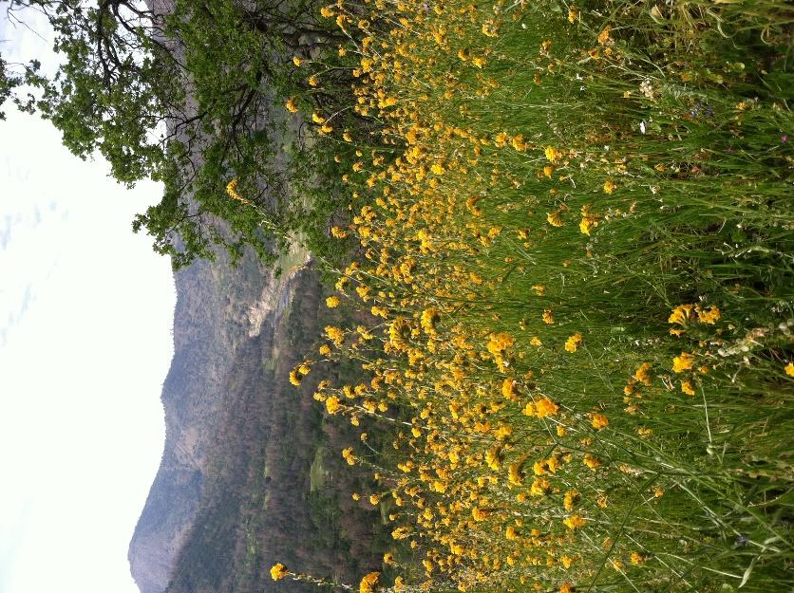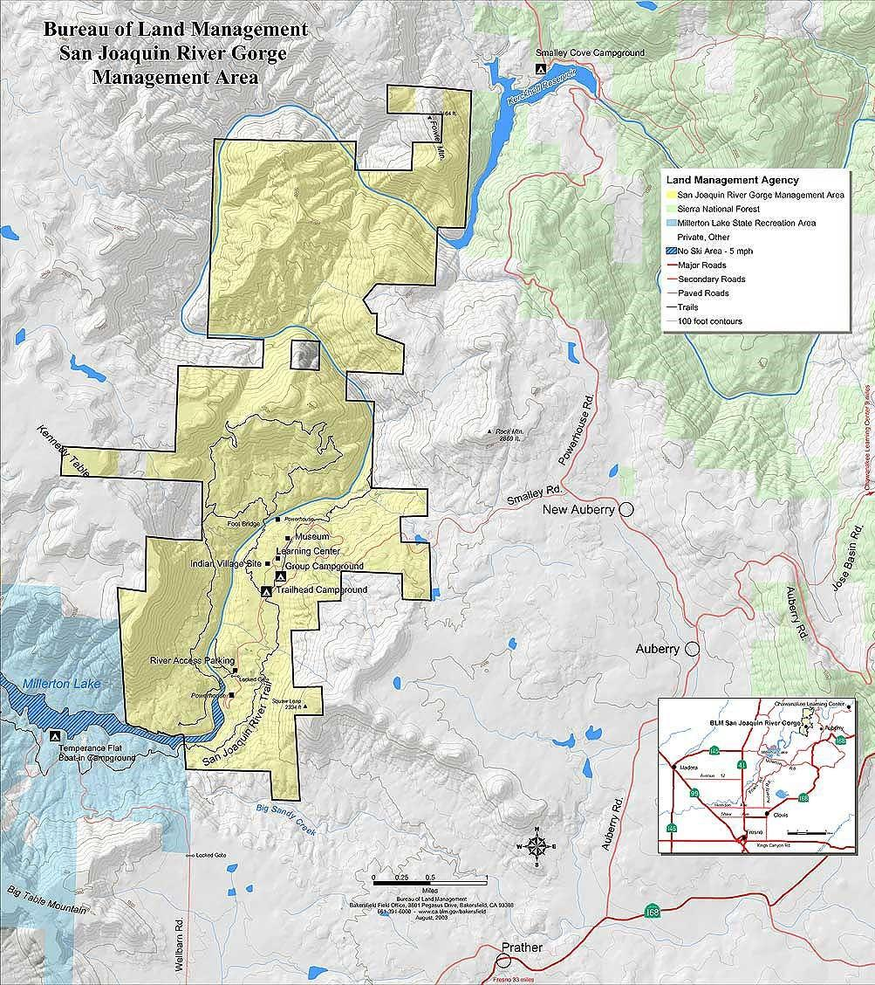

Join us for a variety of programs from formal activities conforming to California education standards for classrooms, to activities for scouts and the public. These programs provide great opportunities to learn about the environment scientifically in a setting that has a rich and historic past.

Contact the Bureau of Land Management office at 559-855-3492 for program and reservation information.

Visit the small museum with local information and displays, a gift shop, an outdoor classroom and occasional guided programs. Explore a reproduction of an Indian village with a sweat lodge, cedar bark houses and an acorn granary. Stroll down a nature trail offering an array of native plants used by indigenous ancestors. Investigate a bedrock mortar site and an archaeological station for simulated excavations.

Several native peoples chose to live here for thousands of years, enriching the cultural value of the entire area.

and spring scenery. For equestrians, there is a horse camp available with corrals and walk-in campsites.

Scenic trails from the Madera side offer a six-mile hiking loop along the ridge with an additional four-mile trail along the river.  The sixteen-mile San Joaquin River Trail begins on the Fresno side.

The SJRG is in the heart of wildland-urban interface, accessible by paved roads year round. The San Joaquin River has quite a story to tell concerning historic and contemporary struggles over water and power. This area contains many educational opportunities to investigate its ecological, cultural and historical diversity.

**Equestrian/footbridge crossing the San Joaquin River**

**San Joaquin River Gorge Recreational Area: SJRG**

Welcome to the San Joaquin River Gorge Recreation Area, the best kept secret in this area! Come visit the last wild and scenic portion of the San Joaquin River. Connect with nature through an abundance of outdoor opportunities for families, friends, scouts, and other groups. It’s easy, and accessible year-round!

The SJRG is located along the San Joaquin River separating Fresno and Madera Counties. Come explore almost 7,000 acres ready for hiking, picnicking, hunting, single family and group camping.

There are 22 plus miles of hiking and riding trail opportunities that provide anglers and mountain bikers with beautiful fall, winter

**Fr.O.G.**

**Friends of the Gorge**

The San Joaquin River Gorge Recreation Area is

managed by the United States Department

of Interior, Bureau of Land Management (BLM).

From Fresno, take Highway 168 to Auberry Road,

north through town to Powerhouse Road, left on Smalley Road, until you see the campground (about 3 miles).

P. O. Box 248, Auberry, CA 93602, 559-855-3492

~~~~~~~~

***Friends of the San Joaquin River Gorge*** is a non-profit 501(c)(3) established in 2015 to assist the BLM.

**Fr**iends **O**f the San Joaquin River **G**orge (**F**r.**O.G**) seek

to ignite, inspire and cultivate visitor’s connection with our local nature, culture and history.

Our organization is designed to engage, and foster stewardship and promote ethical preservation of natural, cultural and historic resources. We aim to connect partners, patrons, visitors and volunteers to our communities via evocative educational, interactive and hands-on experiences.

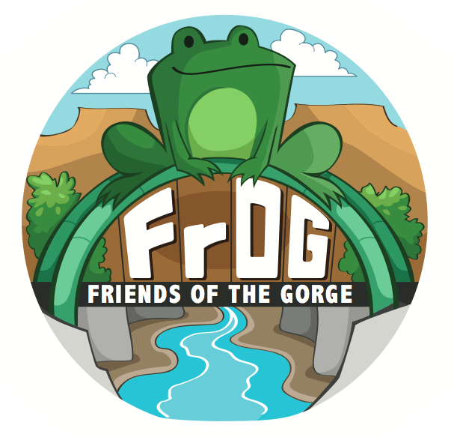

Join us!  *friendsofsjrg@gmail.com*